Project Plan
Author(s) | Adrian Gawryszewski  James Barnett  Samuel Clements  Stoyko Veselinov Kodzhabashev
Configuration Reference | Unknown
Last Update | 15/02/13
Version Number | 1.2
Document Status | Final

Table of Contents
Diagrams 4
Account Management Use Case Diagram 4
Offers Use Case Diagram 5
Project Plan 6
Gantt Chart 6
Event Timeline 7
Risk Assessment 9
User Interaction Design 12
Purpose of this document 12
Scope 12
Objectives 12
Account management 13
Register/Unregister 13
Login/Logoff 17
Offers 18
Friend Requests 18
Fight request 18
Breed 19
Trade 19
Notifications 19
Accept an offer 20
Other Views 20
Home Screen 20
View Friends Monsters 21
Profile View 21
Choose a monster 22
REFERENCES 22
DOCUMENT CHANGE HISTORY 22

Diagrams

Account Management Use Case Diagram

Offers Use Case Diagram

Project Plan

Gantt Chart

Event Timeline

Main Event | Date | What took place and actions of project members
Arrange project team positions | 08/10/12 | Have a group meeting to decide positions in the team.
Introduction and details of the proposed system | 08/10/12 | Introduce the team members to the task ahead and give details of the system and discuss plans ahead.
First part of project documentation to be delivered | 15/10/12 | To allocate tasks and plan ahead so that work is collaborated on time for the first deliverable.
First deliverable | 29/10/12 | To deliver the work by this date.
Diagrams | 29/10/12 | To create a class and component diagram to give an understanding of the system structure.
Test identification | 29/10/12 | To identify tests that can be carried out on the finished system.
Standards meeting | 29/10/12 | To attend a standards meeting to discuss with the other group standards to be used.
Test Specification | 29/10/12 | To create the test specification for the final system so that it could be delivered.
Allocating work for coding week | 29/10/12 | To split up the workload so it was fairly distributed to members of the project for coding week including documentation.
Skeleton code | 05/11/12 | To prepare the skeleton code ready for the implementation of main methods.
Standards meeting | 12/11/12 | To attend a standards meeting to discuss with the other group standards to be used.
Second deliverable | 12/11/12 | To deliver all required documentation by this point.
Architectural and interface description | 12/11/12 | To put together the architectural description and interface description.
Start of coding | 12/11/12 | To start coding.
References | 26/11/12 | To put together references and appendices for the project.
Standards meeting | 26/11/12 | To attend a standards meeting to discuss with the other group standards to be used.
Third deliverable | 03/12/12 | To deliver all the required documentation up to this point which included the test specification.
Prototype demo submission | 10/12/12 | To research prototyping software to be used.
Integration and testing week | 28/01/12 | This week will be used to implement all the main methods in terms of coding and bring together the application in terms of the web interface and the back end code.
Fourth deliverable | 03/02/12 | To deliver the application to the end user.
Final deliverable | 18/02/12 | To deliver all of the work including the documentation.

Risk Assessment

This will look at various risks that can occur during the projects life. Considerations will be made and based on the risks, that can or may arise, actions will be put in place to either stop them occurring or to help recovery in such a situation.

Due to the nature of this project, there are not as many risks as there would be if this were a real life project. For example, there are no funding considerations to take into account, there are no staffing with top talent issues as the groups were chosen by the department and there are not as many software issues to take into consideration given that the university provides all the adequate software needed to successfully complete the project as required.

Risk | Action To Take
One of the major risks to the project is group members may become ill, fall behind or have a number of other personal issues to deal with that can have a direct impact on their productivity in terms of the project. If a project member falls behind there is a chance it could have an impact on their whole project productivity and therefore cause major problems in getting the project completed on time. | To combat this there are a number of things that can be done. Members who are ill shall be required to alert the project manager as soon as possible if they know it is likely that they are going to be off for some time so the work they had been allocated can be given to another member in the group and the whole project is not held back. If a member can't attend a meeting or meet a deadline they should also inform the project manager so that the project manager knows why. Time at the end of the project can also be set so that those that need to catch up on work can do so.
There is a risk that the project manager or quality assurance manager can become ill or cannot attend meetings for personal reasons. | To help stop this having severe consequences on the project work deputy roles have been given out to other members in the group. These then from attending meetings themselves should be able to pick up where those in the more senior positions left off if they are to become ill or not able to attend.
Group member turnover is another key risk. If a key programmer who has done most of the code just decides to drop out of university and there is no one else with understanding of the code that has been created it can either entirely derail the project or set the project back by quite a bit. | It's therefore essential that at least a couple of group members are working on the code so that if personnel leave for whatever reason there is someone there to carry on the implementation and update the other members of what is going on in terms of the implementation and integration of the application.
There is a risk that a project member may have issues with their own personal hardware and lose important documentation or code that they have themselves worked on. | To overcome this it is suggested that as soon as a piece of work is completed it is not only backed up on another device or online but submitted to the git repository so that the other members can sync with it and they will then themselves have a copy of the work done. More group members having a copy of completed work minimises the risk of losing it.
Communication breakdown between groups is possibly one of the biggest threats to this project in terms of risk. If standards are not set by groups and a decision is made with a strict understanding from all involved then there is a major problem whereby the applications created are unlikely to be able to communicate with one another. This would then mean that the project fails to deliver on one of the requirements set out at the start of the project in server communication. | To deal with this effectively it is important a number of standards meetings take place so each group is kept in the loop in terms of what standards are being used and why.
Another threat is there could be a loss of internet connection which holds back work production on the project. For example; if the on-campus network has connection problems during coding week this may cause synchronisation errors which may lead to lack of productivity. It may also stop work being able to be accessed if it is all stored online and there are no offline copies stored to be readily worked on. | To overcome this the group should keep an offline copy of all work on a regular basis by syncing with the Git repository so that if there is a connection failure they can carry on doing work on an offline copy and then sync at a time when connectivity is restored.
Lack of understanding from certain group members can also be a problem for any group project. If there is a lack of understanding and a member has been allocated work they may not do the required work and instead do something else believing they are doing the right thing. | To overcome this it is important that if group members have any doubts or misunderstandings about a piece of allocated work that they speak to the project manager to come to an understanding on the issue.
The scope is another issue. The project requirements and features listed may be beyond that of what the development team can deliver in the time available. | Assign the appropriate tasks to the group members with the skills to carry out those tasks efficiently and set work in accordance to project members strengths.
Another risk is developing the wrong user interface. As the front of the application it is important that the user interface is as required with the functionality set in the project requirements. Failure to do so could mean that the customer is unhappy with the end product. | To overcome this it is important that the goals are understood and that the user interface does exactly what it is meant to do without confusing the user. A good understanding of its purpose means it is likely to be implemented correctly and give the end user a more enjoyable experience using the software. If this were a real world project then surveys could also be handed out to the public to receive feedback on the user interface design.
Plagiarism is a massive risk to the group project as one person committing such an offence could have consequences on the project as a whole and cause problems. This also applies to a real world project whereby committing plagiarism could not only have productivity implications but financial and legal implications as well. | To overcome this it is essential that all code is checked and verified and that each user submits work clearly identifying the author or creator of the work so if plagiarism is an issue it is easy to identify the person responsible. Git also helps with this as submits are recorded so its easy to backtrack and see who submitted the work.

User Interaction Design

Purpose of this document
This document describes the user interaction design for the application.

Scope
This document covers the possible interactions a user may have with the end product.

Objectives
The objectives of this document are to:
- Describe all possible user interactions with the end product, without any reference to technical aspects of the product.

Account management
When a user starts playing the ‘Monster Mash’ game, they will first have to register and then login in order to start playing. The homepage for the game will display options for the user to provide an email and password to login, or a button to register.

Register/Unregister
The first step you need to make in order to play the game is to create an account. When you click on the “register” button, you will be taken to another page where you will be able to fill in your information, including an email and password. When this has been filled in, the user will be able to click a button at the bottom of the page to continue. A page will then be displayed telling the user if the action was successful or not.

Pic 1. Registration box – registration.jsp
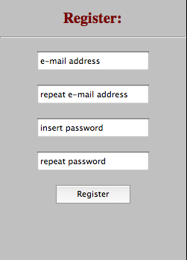

Users can remove their account with the “unregister” button placed on MyProfile site. Again, a page will then be displayed telling the user if the action was successful or not.
Pic 2. Piece of MyProfile.jsp containing unregister button.
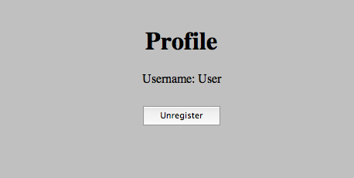

Login/Logoff

A login form will be displayed on the homepage. The user will need to enter the correct account details, and will then be taken to their account page. If the account details are incorrect, they will be returned to the home page and shown a message explaining this. Underneath the form will be an option to register.
Pic. 3 Login box – index.jsp
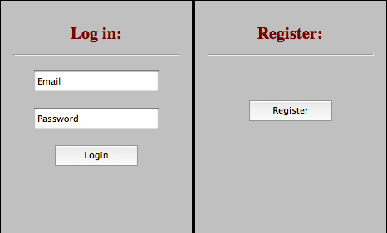

Once the user has logged into their account, they will be able to see a logoff button. Pressing it will immediately take them out of the game and back to the home page of the game.

Pic 4. Menu bar tabs contains Log Out button.

Offers
There are several types of user interaction that can be described in terms of “offers”, where one user offers a request to another user, who then has the chance to either accept or reject the offer. There are four interactions that work this way:

Friend Requests
To send friend request to another player we need to insert friends name (email address) in a text box, placed below friends list and press “Add” button. After that a friend request will occur in a notifications panel.

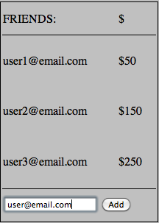
Pic 4. Friends table containing a textfield.

When click on friend request in notification panel you will be redirected to new window, where you will be able to accept or decline friends request.

Pic. 5 Friend request

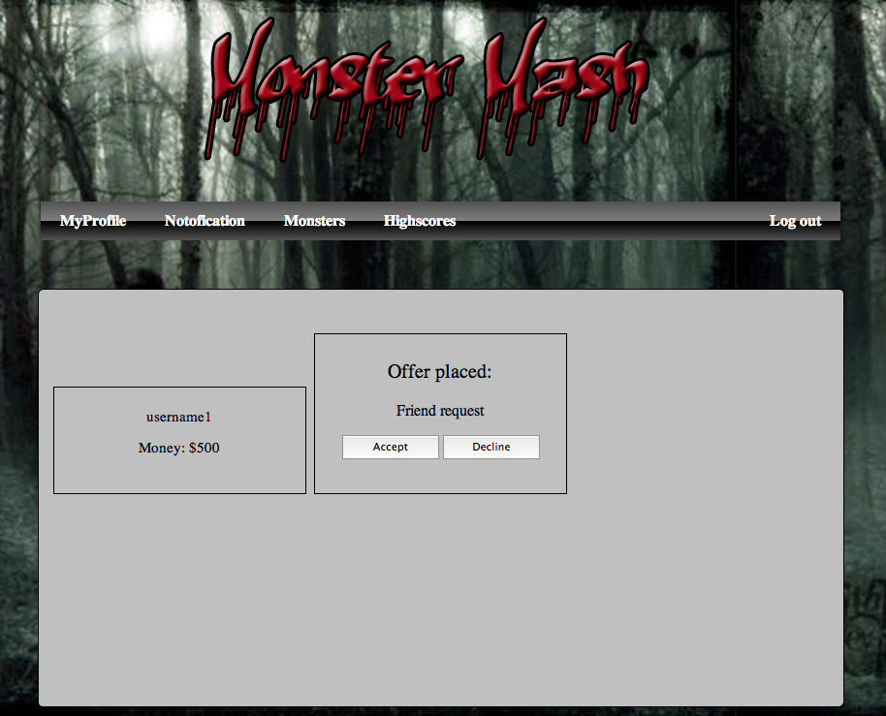
If offer is accepted a new friend occurs in your friend table. From now on you can send offers to this player.

Fight request
Sends fight request to another player from our friends list. (You have to specify amount of money you want to bet, monsters you have picked). Your opponent has to accept your offer, otherwise any action won't be taken. If accepted monsters proceed to fight. After the fight a winner receives money reward.
As a result of any fight your monster can be injured or die. Injury may reduce the monsters attributes, and death will remove it from the owners list of owned monsters.

Breed
Sends breed request to all users from your friends list. You have to pick a monster you want to offer to breed and price. If your offer is accepted new monster is created (his attributes depends on his parents attributes). Otherwise nothing happens.

Trade
This interaction can occurs in three different cases:
- You may want to buy your friends monster. In this case you offer specified amount of money (I assume that every monster has it own value). If accepted, then monster is transferred to your monster farm and the other side receives payment.
- You may want to swap monsters with your friend. In this case you pick monsters you want to swap. If your offer is accepted, replacement occurs.
- You may want to sell your monster in order to get extra money. In this case you post your offer with a price. Request is sent to all users on your friends list. If any of them accepts your proposal sale occurs. Monster is transferred to your friend's farm and you receive payment.

Notifications
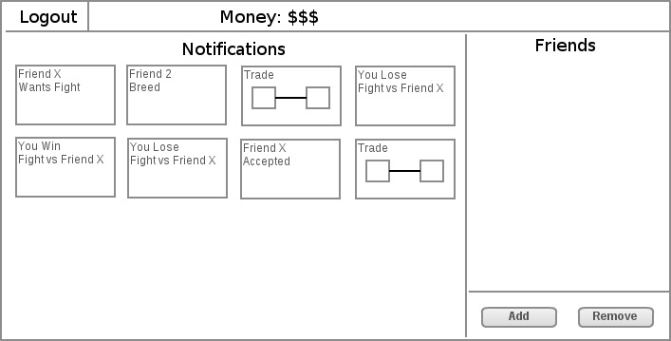
Once people have made offers to you, they will appear on the notifications page. Clicking on an offer will take the user to the 'Accept offer' page.

Accept an offer
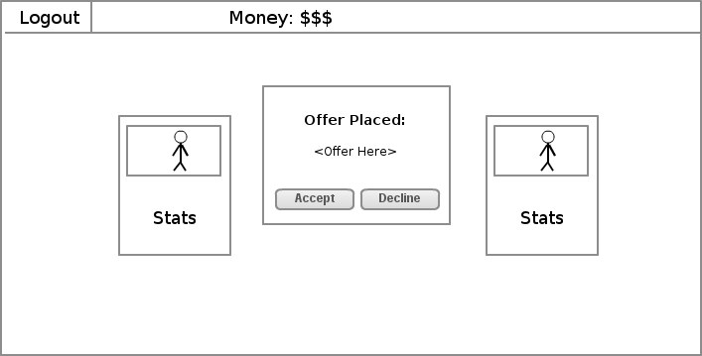
A user can select an offer, which will then show this screen, displaying details of the offer to be accepted. The details will be based on whether the offer is a friend request, or a monster trade/breed/fight. Either the friends or the monsters involved will be shown on the left and right, as a small card containing their stats. In the centre will be buttons to accept and reject the offer.

When the user continues, they will be taken back to the previous page and shown a message telling them that the offer has been accepted or rejected.

Other Views

Home Screen
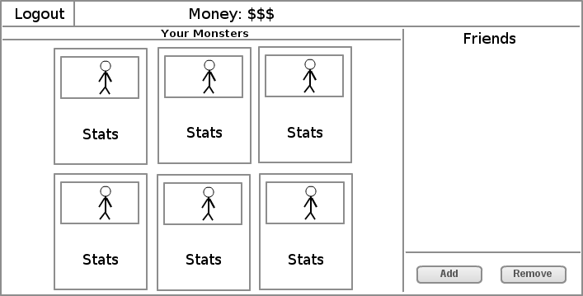
From the main home screen you can see a panel of your monsters, a list of your friends on the far right and an option to add and remove friends. You can also logout using the logout button at the top left corner. The money you currently have is displayed at the top.

View Friends Monsters
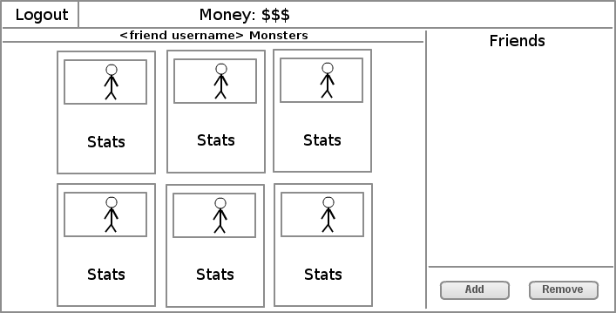
On this page will be a status bar that will tell you the username of your friend so you know you are on the right page. Below that you will see the main panel which will display the monsters that your friend has and the stats for each monster. On the far right will be a list of friends and an option to add and remove them.

Profile View
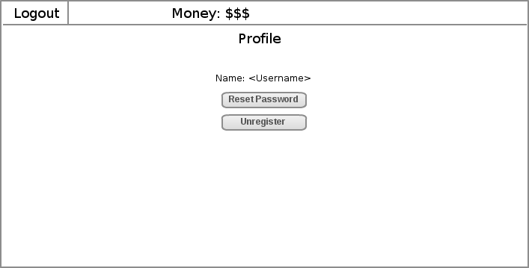
On this page you can see your username and two buttons. One button gives you the option to reset your password whereas the other is to unregister. You can also logout using the logout button at the top left corner.

Choose a monster
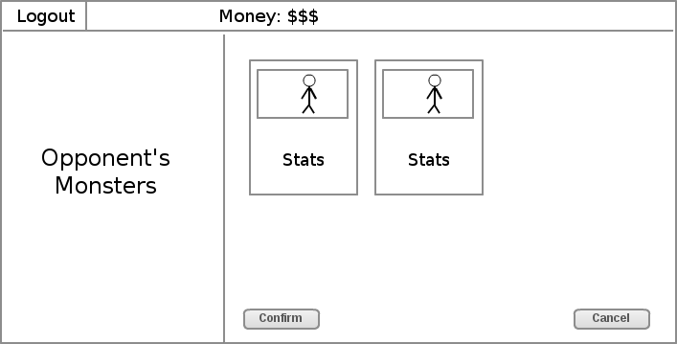
On this page you will see a logout button in the top left corner. Below that in the left panel you will see a message telling you that you are viewing your opponent’s monsters. On the right side is now the main panel which will display a monster to select for fighting, buying or breeding. In the main bar at the top you will see the money you currently have and at the bottom will be two buttons. One will be ‘confirm’ to carry through an action whereas the other will be ‘cancel’ to go back to the main screen.

REFERENCES
This section is an automatic bibliography.

DOCUMENT CHANGE HISTORY
Version | CCF No. | Date | Sections changed | Changed by
1.1 | N/A | 31/10/12 | Corrected document to be inline with the General Documentation Standards | Samuel Clements
1.2 | N/A | 15/02/13 | Put all required documents into one file so that it can be submitted once the Gantt chart has been added. | James Barnett

